# Homework: Databases

Problems for homework for the ["Software Technologies" course @ Software University.](https://softuni.bg/trainings/4383/software-technologies-january-2024)  
Submit this document as your homework.

## Address Database:

1. **CREATE DATABASE** named `**address_database**` and USE it:

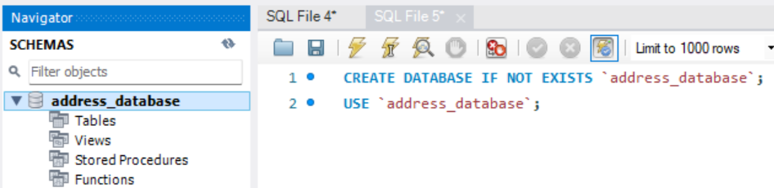

1. **CREATE TABLE** named `**addresses**` with the following columns:
   * **street_number**
   * **street_name**
   * **area**
   * **town**
   * **district**
   * **country**
   * **continent**

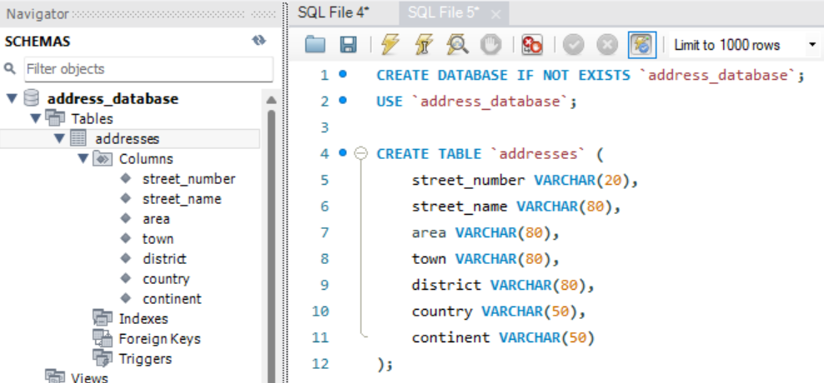

1. We forgot to **add Boolean column**, named `**isCapital**`:

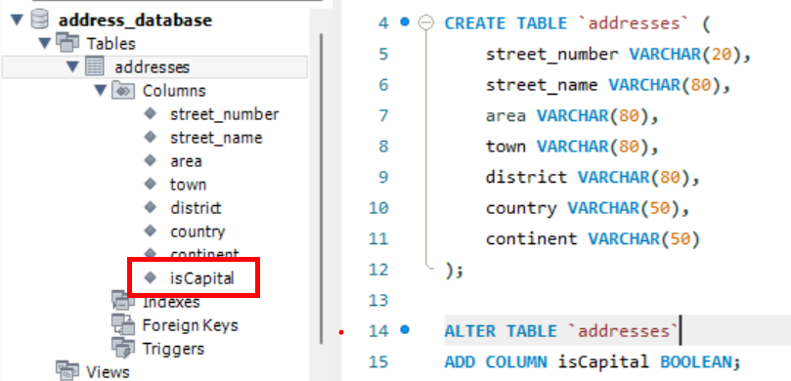

1. **INSERT** records **INTO** the `**address**` table and execute the SQL query:

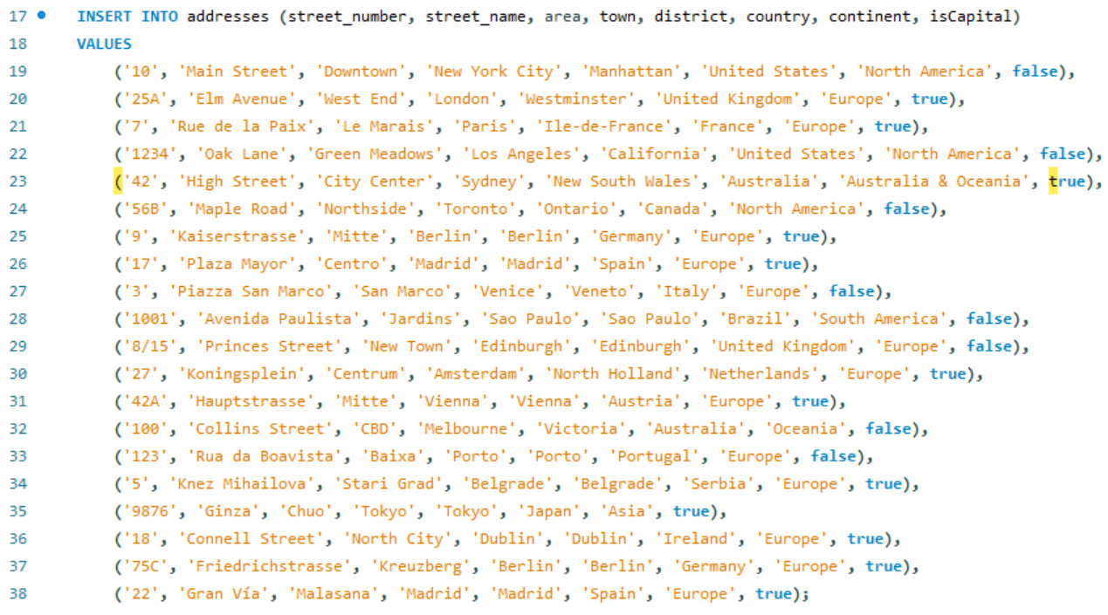

1. **Your task is to execute the proper queries in order to get the following results:**
   * **SELECT all addresses from the `address` table that are located in a capital city.**

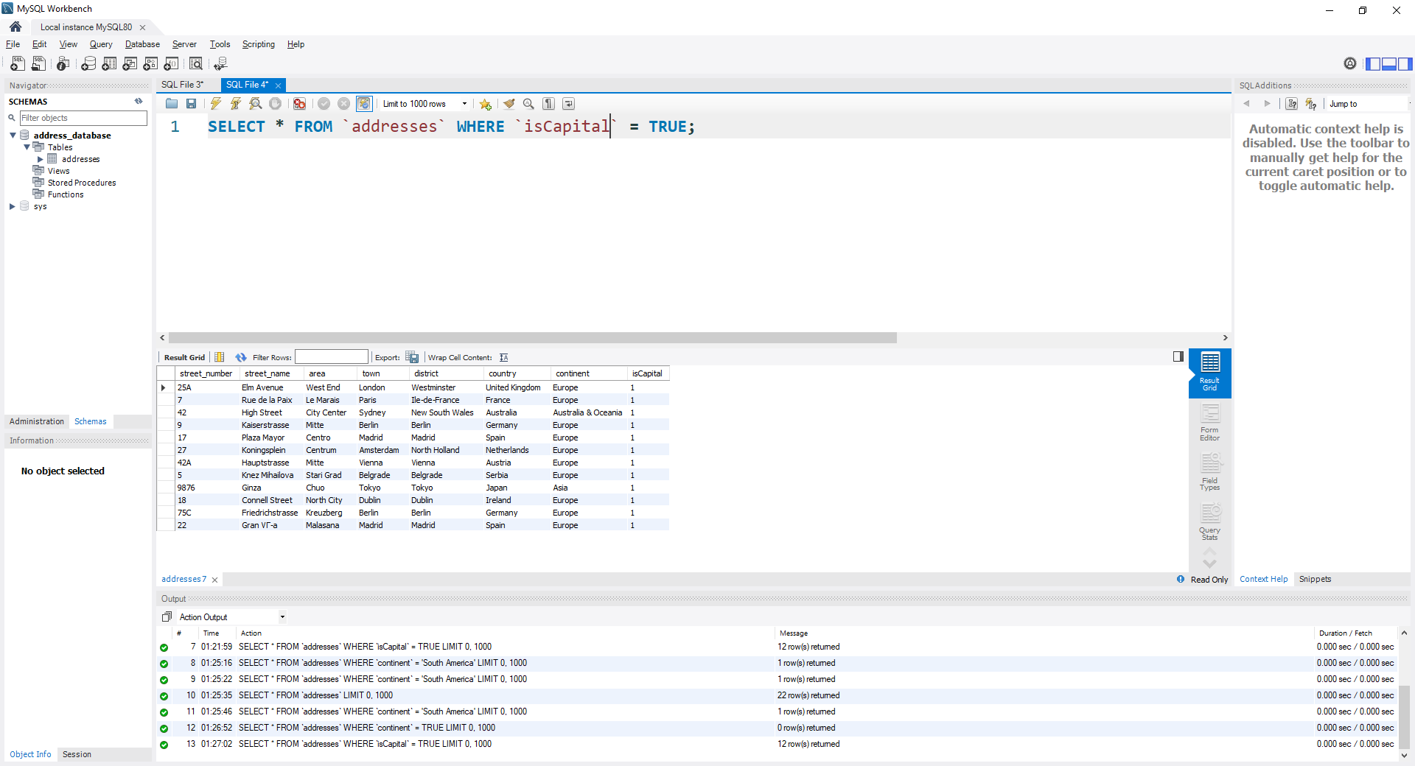

* + **SELECT all addresses from the `address` table that are located in South America.**

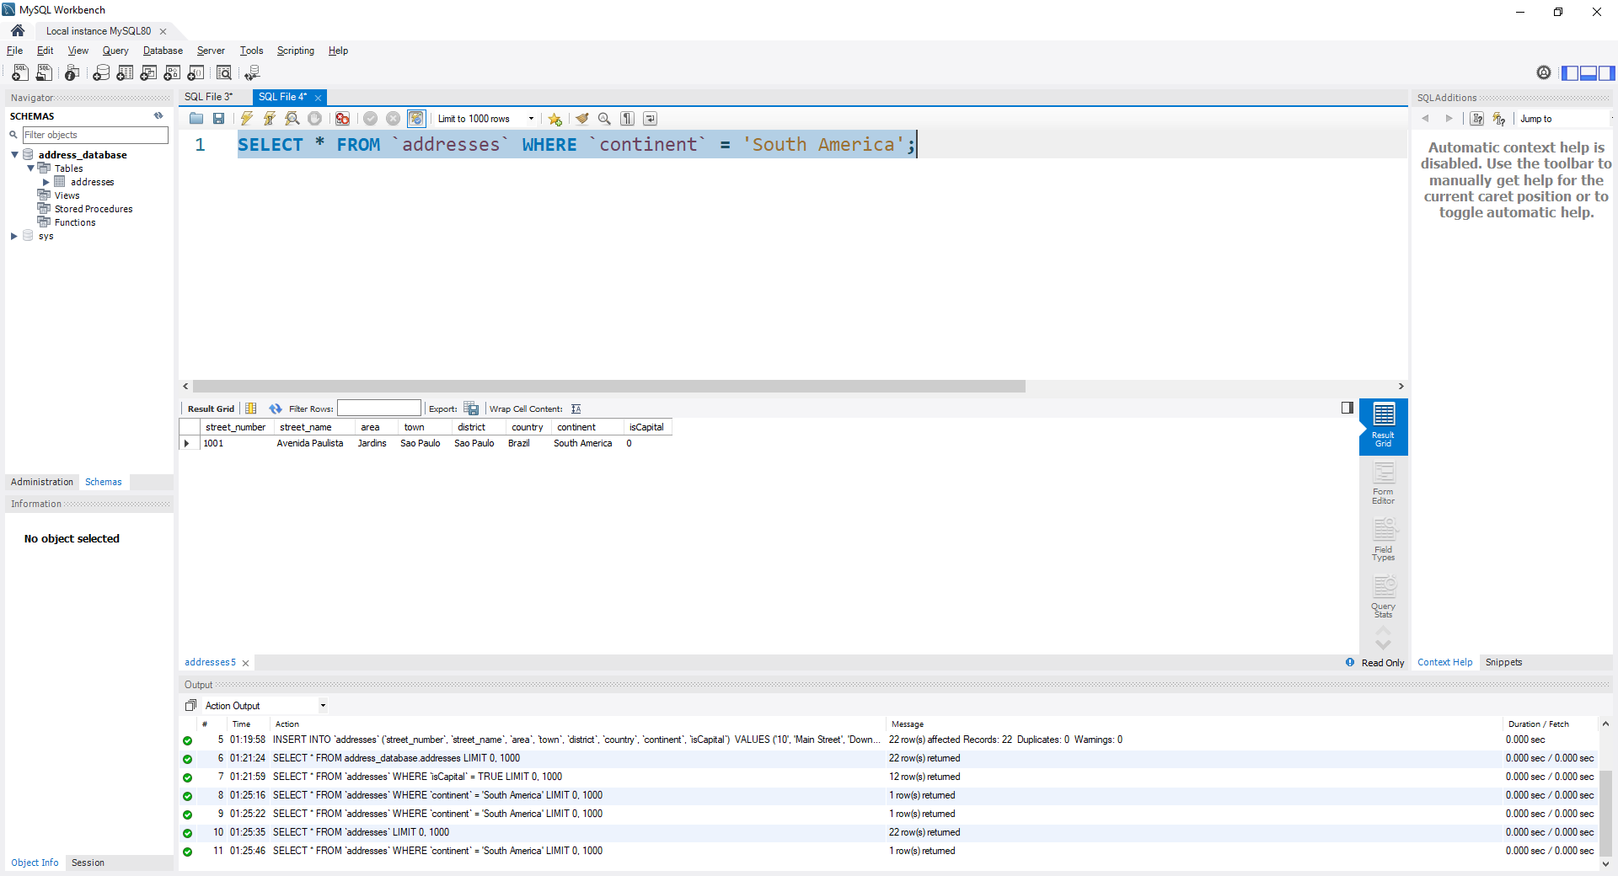

* + **SELECT all addresses from the `address` table that are located in Europe, but only in NON Capital cities.**

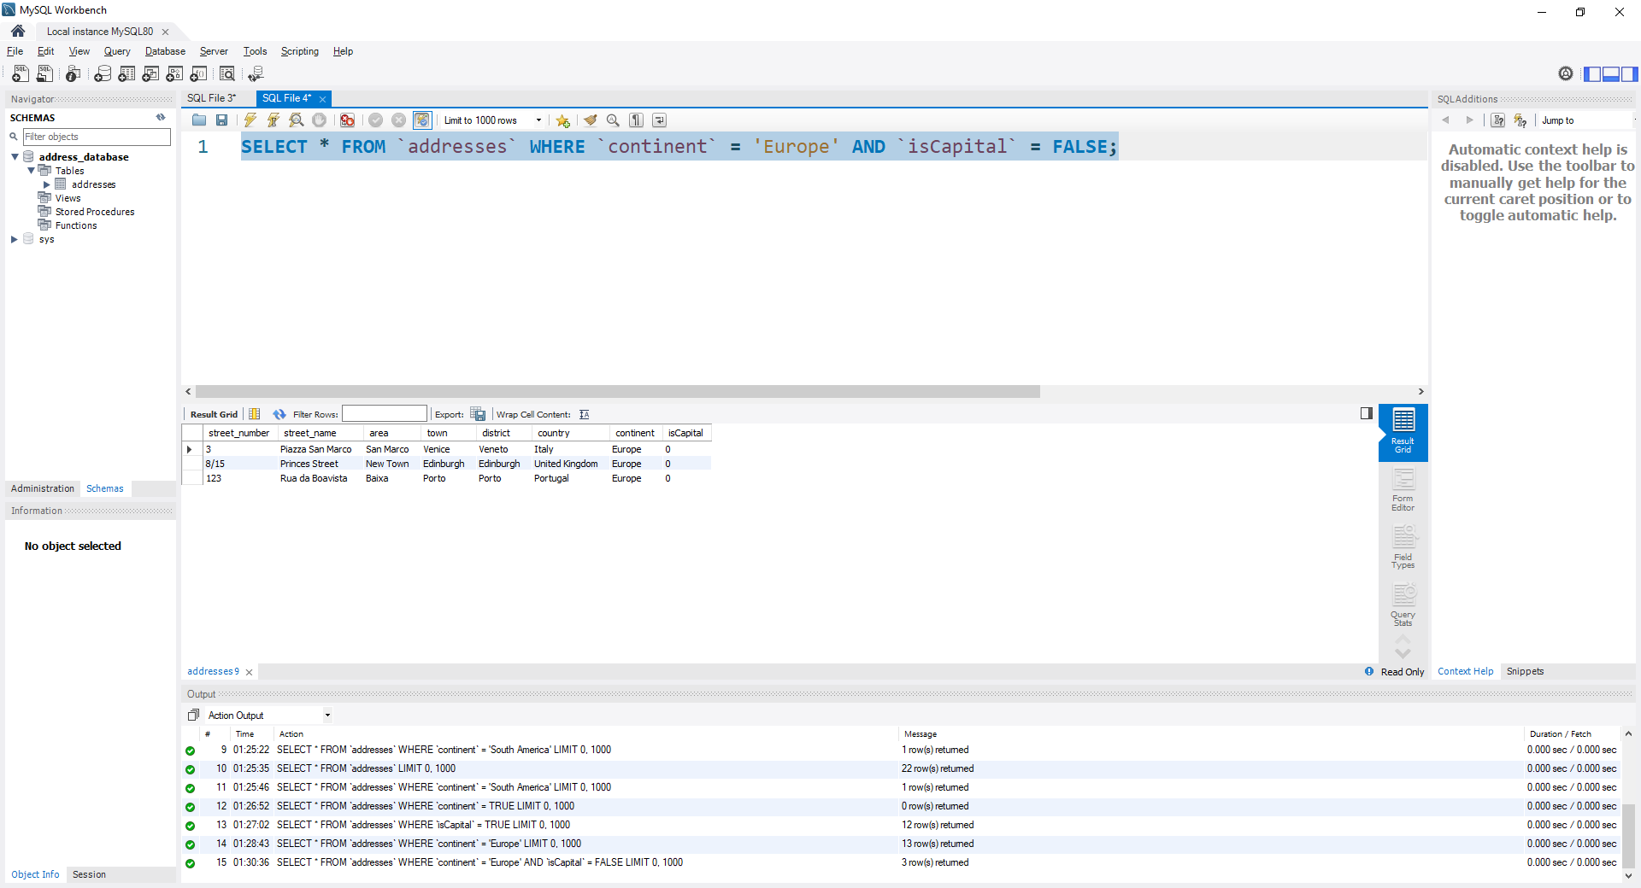

* **Create queries for each condition and place a screenshot after each query !**